**Aditya Kishor**

1. **First problem Solution**

**@Index.html**

<!DOCTYPE html>

<html lang="en">

<head>

  <meta charset="UTF-8">

  <title>Navigation Bar</title>

  <link rel="stylesheet" href="style.css">

</head>

<body>

  <header class="navbar">

    <div class="brand">

      <img src="https://images.pexels.com/photos/210019/pexels-photo-210019.jpeg?cs=srgb&dl=action-asphalt-auto-210019.jpg&fm=jpg" alt="Profile Image" class="profile-img">

      <span class="brand-name">MyBrand</span>

    </div>

    <nav class="nav-links">

      <a href="#home">Home</a>

      <a href="#about">About</a>

      <a href="#services">Services</a>

      <a href="#contact">Contact</a>

    </nav>

  </header>

</body>

</html>

**@Style.CSS**

body {

  margin: 0;

  font-family: Arial, sans-serif;

}

.navbar {

  display: flex;

  align-items: center;

  justify-content: space-between;

  background-color: #333;

  padding: 10px 20px;

}

.brand {

  display: flex;

  align-items: center;

}

.profile-img {

  width: 40px;

  height: 40px;

  border-radius: 50%;

  margin-right: 10px;

}

.brand-name {

  color: #fff;

  font-size: 20px;

  font-weight: bold;

}

.nav-links a {

  color: #fff;

  text-decoration: none;

  margin-left: 20px;

  padding: 6px 10px;

  transition: background-color 0.3s;

}

.nav-links a:hover {

  background-color: #555;

  border-radius: 4px;

}

**@Output**

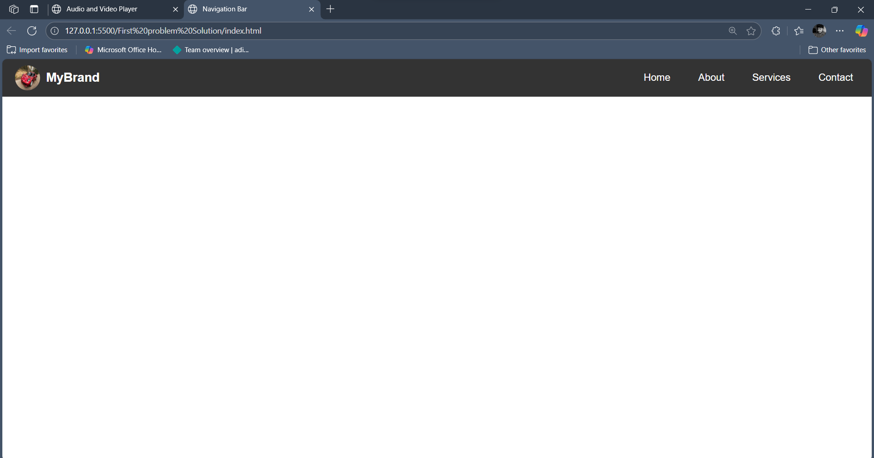

1. **Second Problem solution**

**@Index.html**

<!DOCTYPE html>

<html lang="en">

<head>

  <meta charset="UTF-8">

  <title>Formatted Paragraph</title>

</head>

<body>

  <p>

    FITA is an <b>Online & Offline transformative</b> <i>upskilling platform</i> for working

    tech <s>& business</s> professionals.<sup>*</sup> &copy;

  </p>

</body>

</html>

**@Output:-**

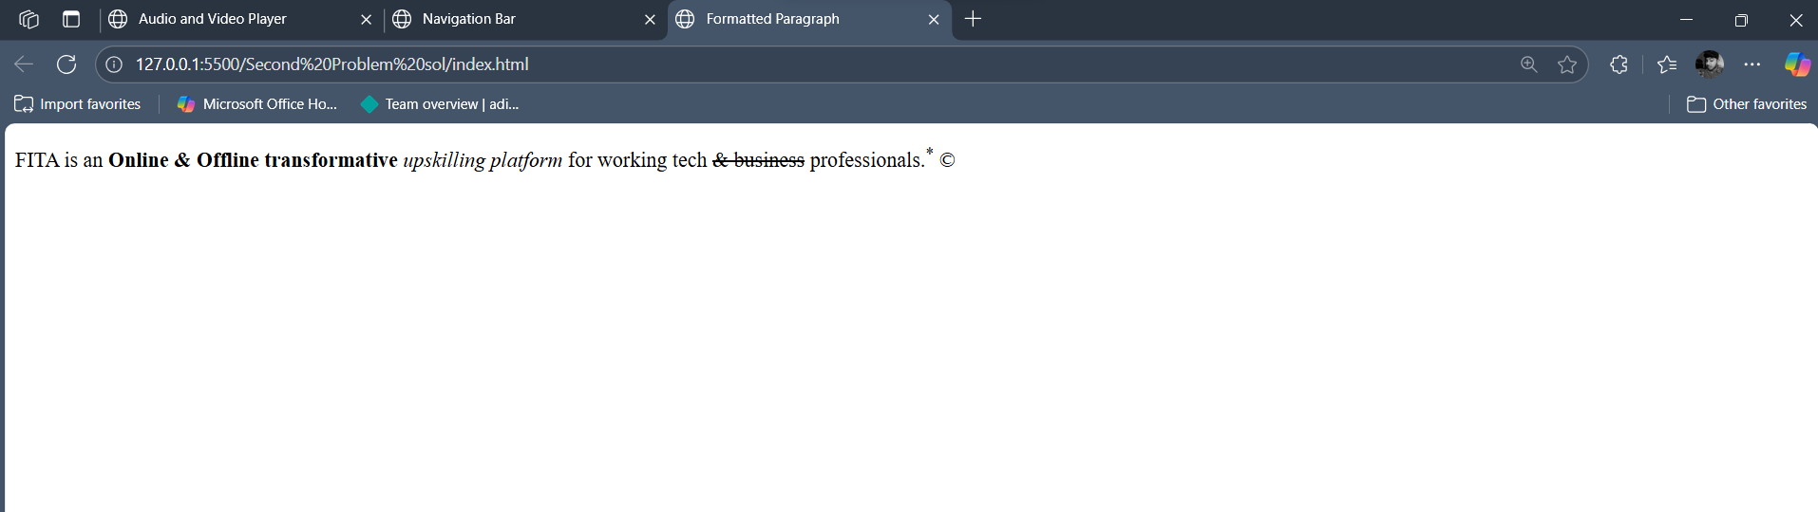

1. **Third Solution**

**@Index.html**

<!DOCTYPE html>

<html lang="en">

<head>

  <meta charset="UTF-8">

  <title>Formatted Paragraph</title>

</head>

<body>

  <p>

    FITA is an <b>Online & Offline transformative</b> <i>upskilling platform</i> for working

    tech <s>& business</s> professionals.<sup>*</sup> &copy;

  </p>

</body>

</html>

**@Output**

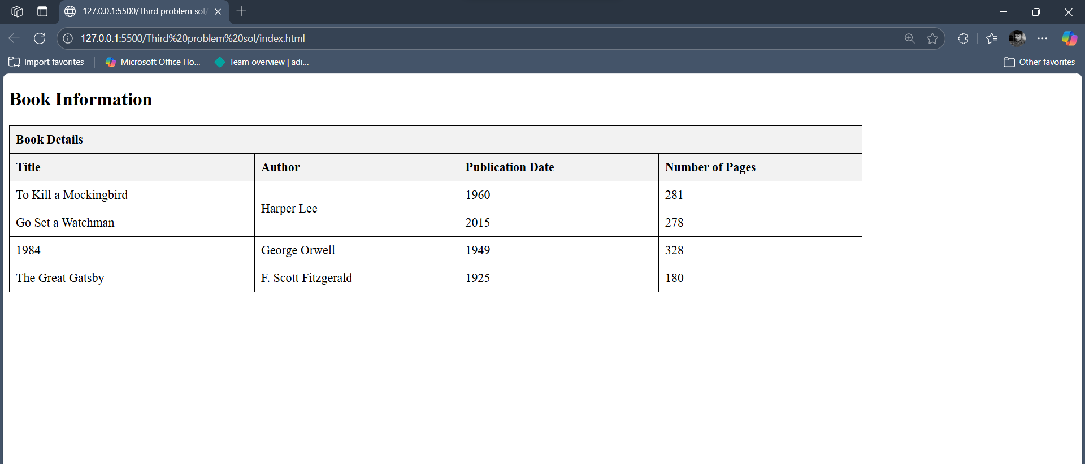

1. **Fourth Solution**

**@Index.html**

<!DOCTYPE html>

<html>

<head>

  <title>Favorite Food Survey</title>

</head>

<body>

  <h2>Favorite Food Survey</h2>

  <form action="#" method="post">

    <label for="name">Name:</label>

    <input type="text" id="name" name="name" required>

    <br><br>

    <label for="age">Age:</label>

    <input type="number" id="age" name="age" required>

    <br><br>

    <label>Gender:</label>

    <input type="radio" id="male" name="gender" value="Male" required>

    <label for="male">Male</label>

    <input type="radio" id="female" name="gender" value="Female">

    <label for="female">Female</label>

    <br><br>

    <label for="food">Favorite Food:</label>

    <input type="text" id="food" name="food" required>

    <br><br>

    <input type="submit" value="Submit">

  </form>

</body>

</html>

**@Output:-**

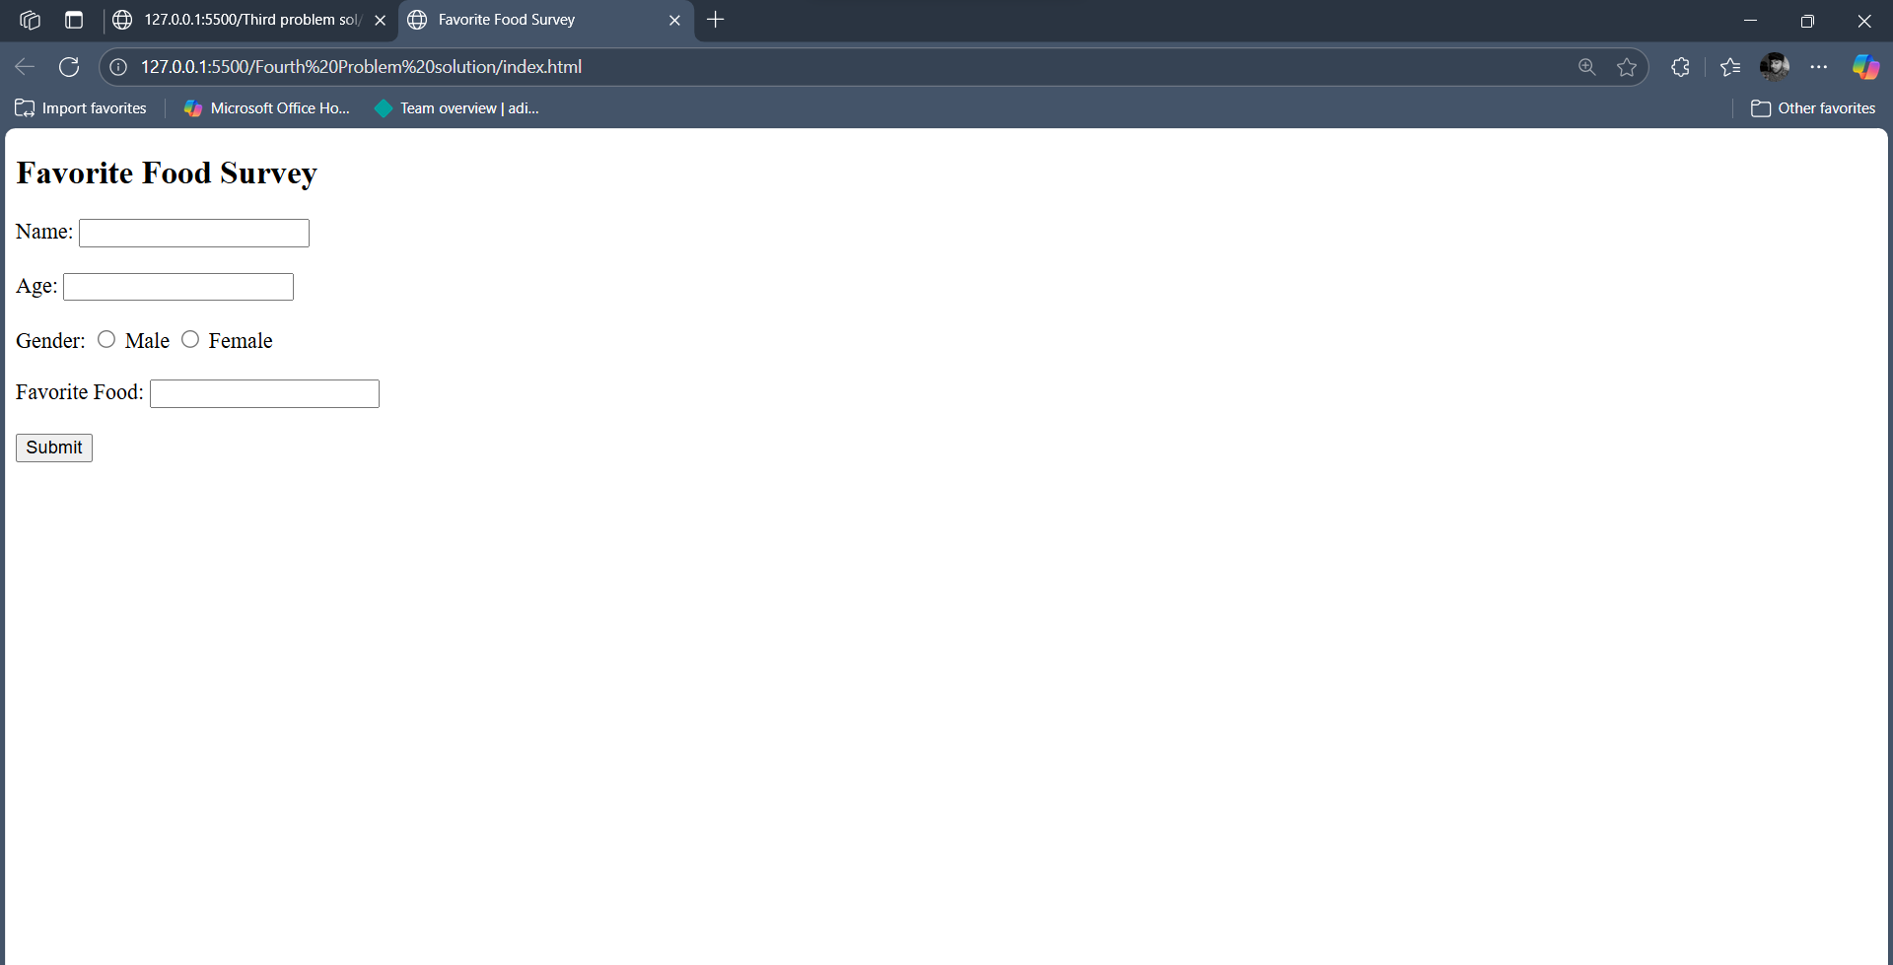

1. **Fifth Solution**
2. <!DOCTYPE html>
3. <html>
4. <head>
5. <title>Lists in HTML</title>
6. <style>
7. ul.square-list {
8. list-style-type: square;
9. }
10. </style>
11. </head>
12. <body>
13. <h2>Ordered List of Cities (Alphabetic)</h2>
14. <ol type="A">
15. <li>New York</li>
16. <li>Tokyo</li>
17. <li>Paris</li>
18. <li>London</li>
19. <li>Dubai</li>
20. </ol>
21. <h2>Unordered List of Beverages (Square)</h2>
22. <ul class="square-list">
23. <li>Coffee</li>
24. <li>Tea</li>
25. <li>Juice</li>
26. </ul>
27. </body>
28. </html>

**@Output**

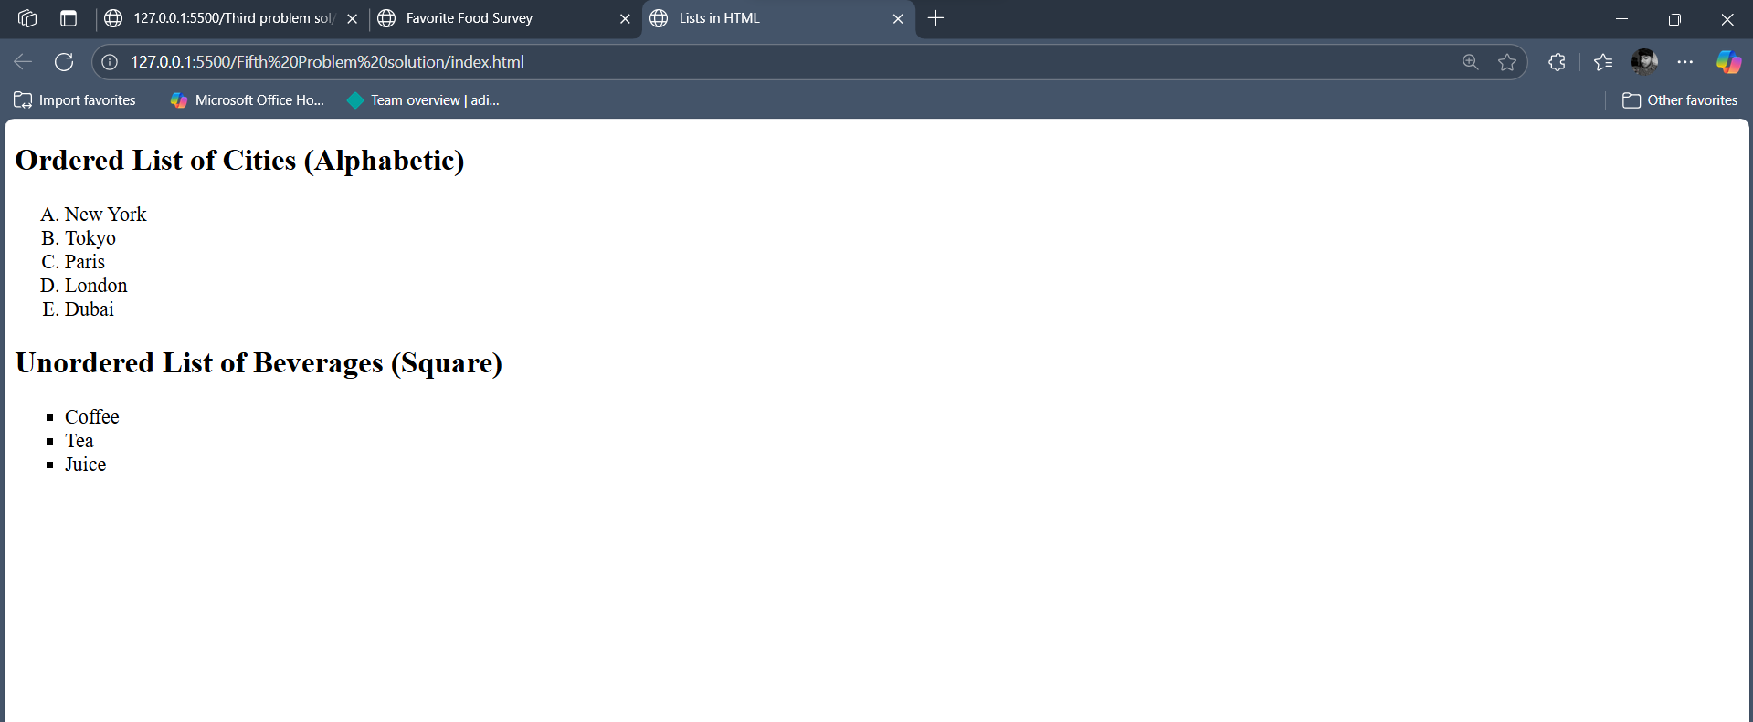

1. **Seventh Solution:-**

**@index**

<!DOCTYPE html>

<html lang="en">

<head>

  <meta charset="UTF-8">

  <title>Box Movement Animation</title>

  <style>

    .container {

      width: 100%;

      height: 100px;

      position: relative;

      background-color: #f0f0f0;

      overflow: hidden;

    }

    .box {

      width: 50px;

      height: 50px;

      background-color: #4CAF50;

      position: absolute;

      animation: moveRight 5s linear infinite;

    }

    @keyframes moveRight {

      0%   { left: 0; }

      100% { left: 100%; }

    }

  </style>

</head>

<body>

  <div class="container">

    <div class="box"></div>

  </div>

</body>

</html>

**@Output:-**

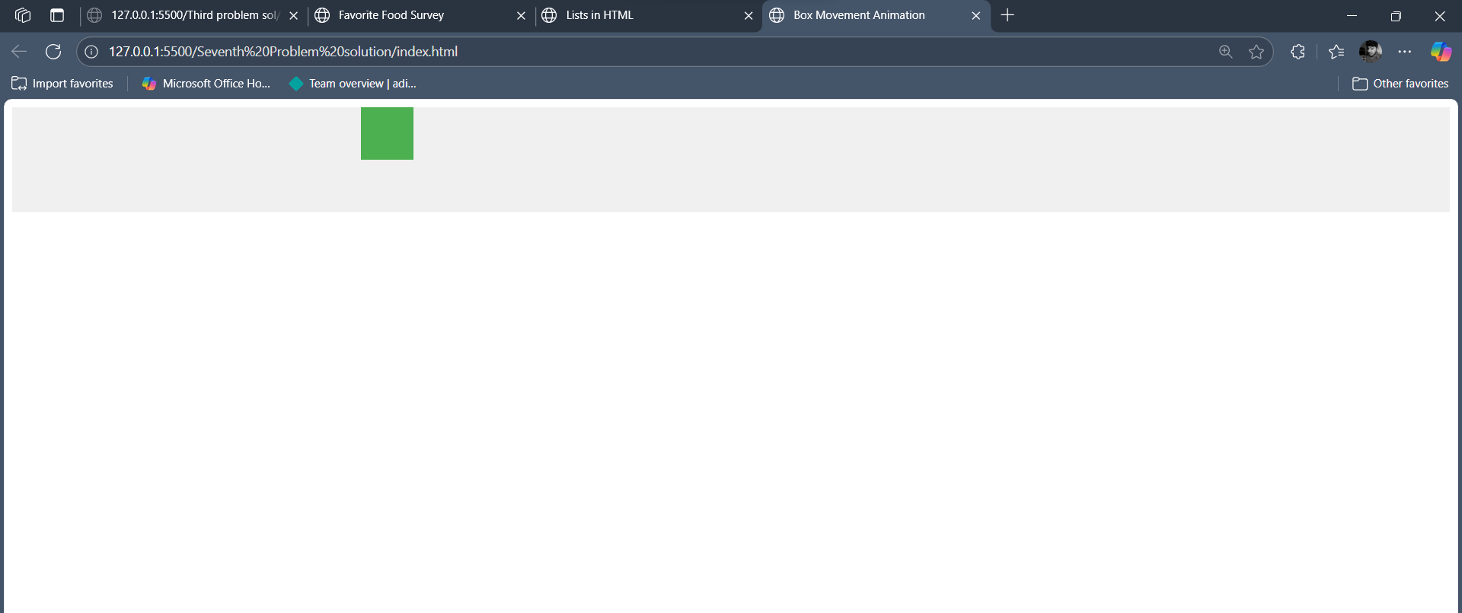

1. **Eigth solution**
2. <!DOCTYPE html>
3. <html lang="en">
4. <head>
5. <meta charset="UTF-8">
6. <title>Transform on Hover</title>
7. <style>
8. .box {
9. width: 150px;
10. height: 150px;
11. background-color: #f37521;
12. transition: transform 0.3s ease;
13. margin: 50px auto;
14. }
15. .box:hover {
16. transform: scale(1.2) rotate(10deg);
17. }
18. </style>
19. </head>
20. <body>
21. <div class="box"></div>
22. </body>
23. </html>

**@Output:-**

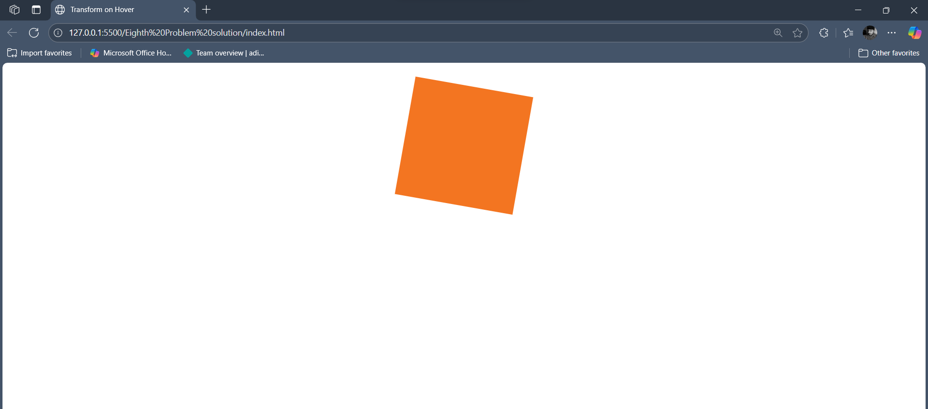

**9. Ninth Solution**

**@html**

<!DOCTYPE html>

<html lang="en">

<head>

  <meta charset="UTF-8">

  <title>Color-Changing Circle</title>

  <style>

    .circle {

      width: 200px;

      height: 200px;

      border-radius: 50%;

      animation: colorChange 8s infinite linear;

    }

    @keyframes colorChange {

      0%   { background-color: red; }

      25%  { background-color: yellow; }

      50%  { background-color: blue; }

      75%  { background-color: green; }

      100% { background-color: red; }

    }

    body {

      display: flex;

      justify-content: center;

      align-items: center;

      height: 100vh;

      margin: 0;

      background: #f0f0f0;

    }

  </style>

</head>

<body>

  <div class="circle"></div>

</body>

</html>

**@Output:-**

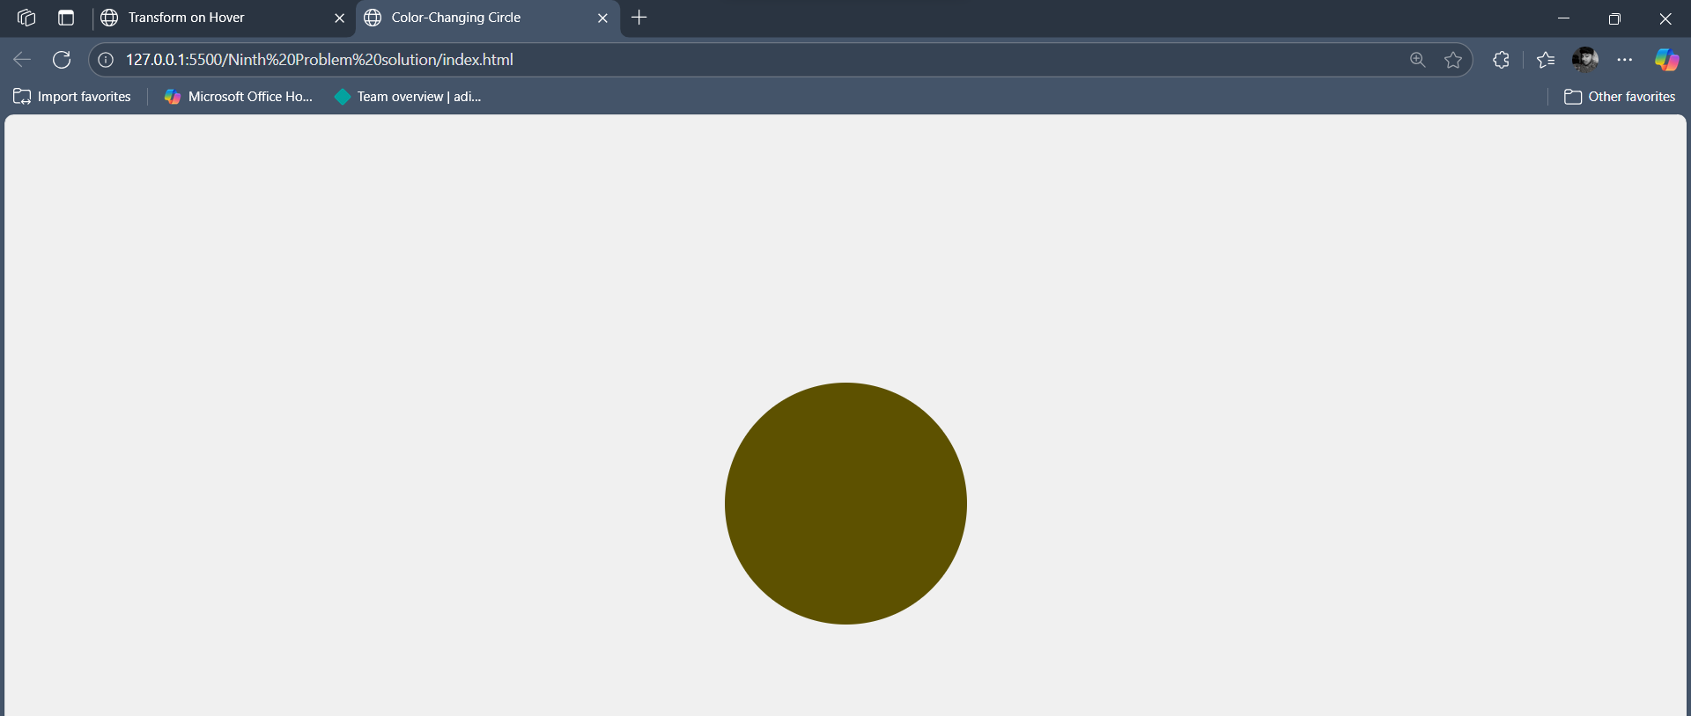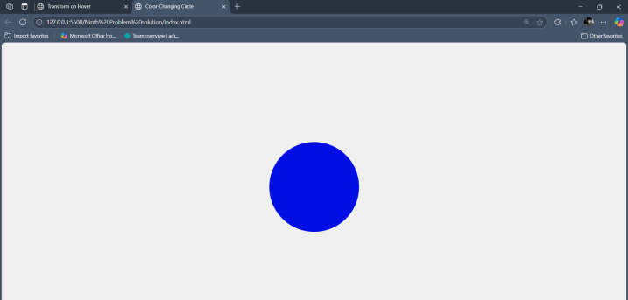

**10. Tenth Solution**

**@html**

<!DOCTYPE html>

<html lang="en">

<head>

  <meta charset="UTF-8">

  <title>Audio and Video Player</title>

</head>

<body>

  <h2>Audio Player</h2>

  <audio controls>

    <source src="Music.mp3" type="audio/mpeg">

    Your browser does not support the audio element.

  </audio>

  <h2>Video Player</h2>

  <video controls autoplay muted poster="https://i.ytimg.com/vi/h8-qemIbXbo/maxresdefault.jpg" width="640">

    <source src="video.mp4" type="video/mp4">

    Your browser does not support the video tag.

  </video>

</body>

</html>

**@Output:-**

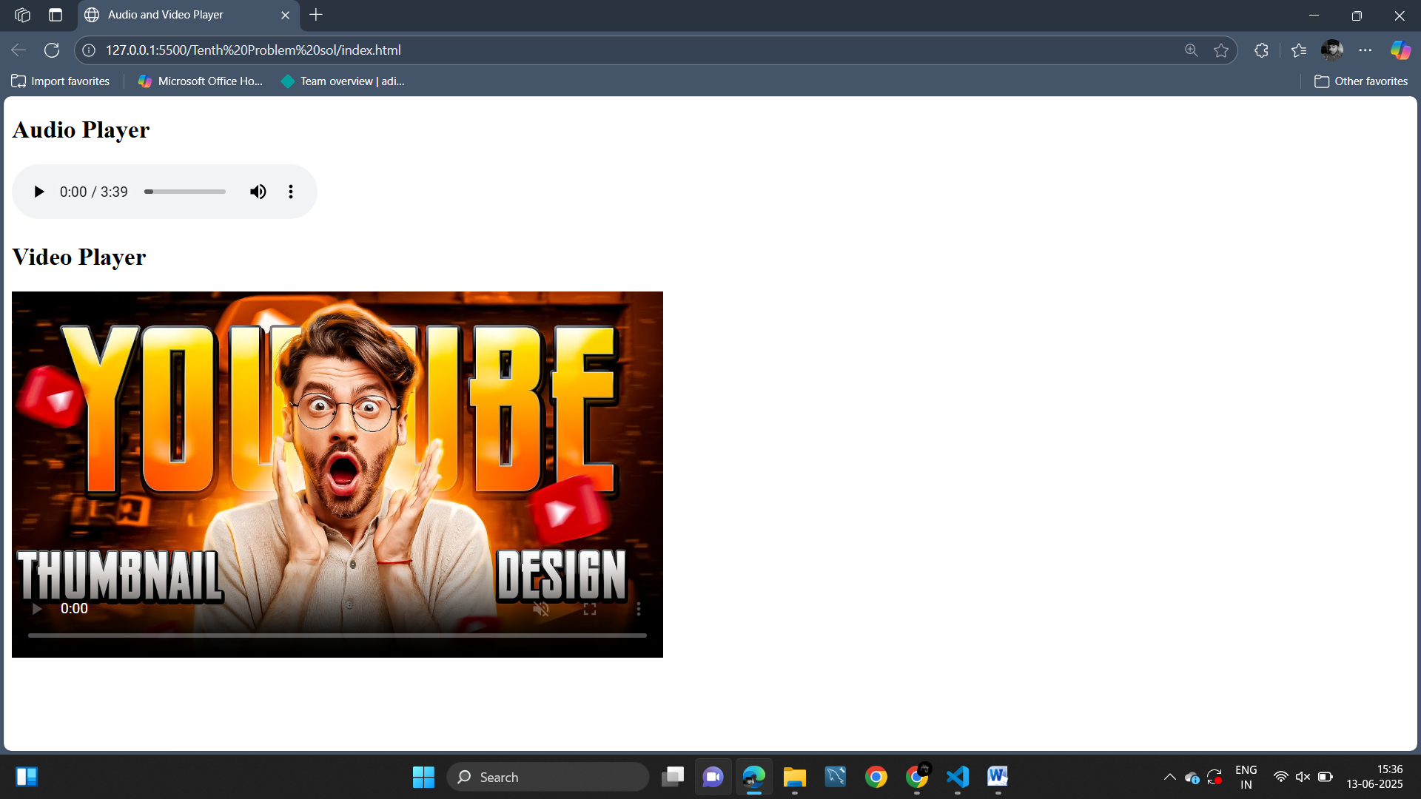

**11. Problem solution**

**@Index.html**

<!DOCTYPE html>

<html lang="en">

<head>

  <meta charset="UTF-8">

  <title>Responsive Card</title>

  <style>

    * {

      box-sizing: border-box;

      margin: 0;

      padding: 0;

    }

    body {

      font-family: Arial, sans-serif;

      background-color: #f4f4f4;

      padding: 20px;

      display: flex;

      justify-content: center;

    }

    .card {

      width: 100%;

      background-color: #fff;

      padding: 20px;

      font-size: 14px;

      text-align: center;

      transition: transform 0.3s;

    }

    .image-section {

      display: none;

    }

    /* ≥ 600px styles */

    @media (min-width: 600px) {

      .card {

        width: 80%;

        font-size: 16px;

        box-shadow: 0 4px 8px rgba(0, 0, 0, 0.2);

        border-radius: 5px;

      }

      .card:hover {

        transform: translateY(-5px);

      }

    }

    /* ≥ 900px styles */

    @media (min-width: 900px) {

      .card {

        display: flex;

        width: 70%;

        font-size: 18px;

        border-radius: 10px;

        text-align: left;

      }

      .image-section {

        display: block;

        flex: 1;

        background: url('https://via.placeholder.com/150') no-repeat center center;

        background-size: cover;

        border-radius: 10px 0 0 10px;

      }

      .content-section {

        flex: 2;

        padding: 20px;

      }

    }

  </style>

</head>

<body>

  <div class="card">

    <div class="image-section"></div>

    <div class="content-section">

      <h2>Responsive Card</h2>

      <p>This card adjusts its layout and style based on screen size using media queries. Try resizing your browser window to see the changes.</p>

    </div>

  </div>

</body>

</html>

**@Output:**

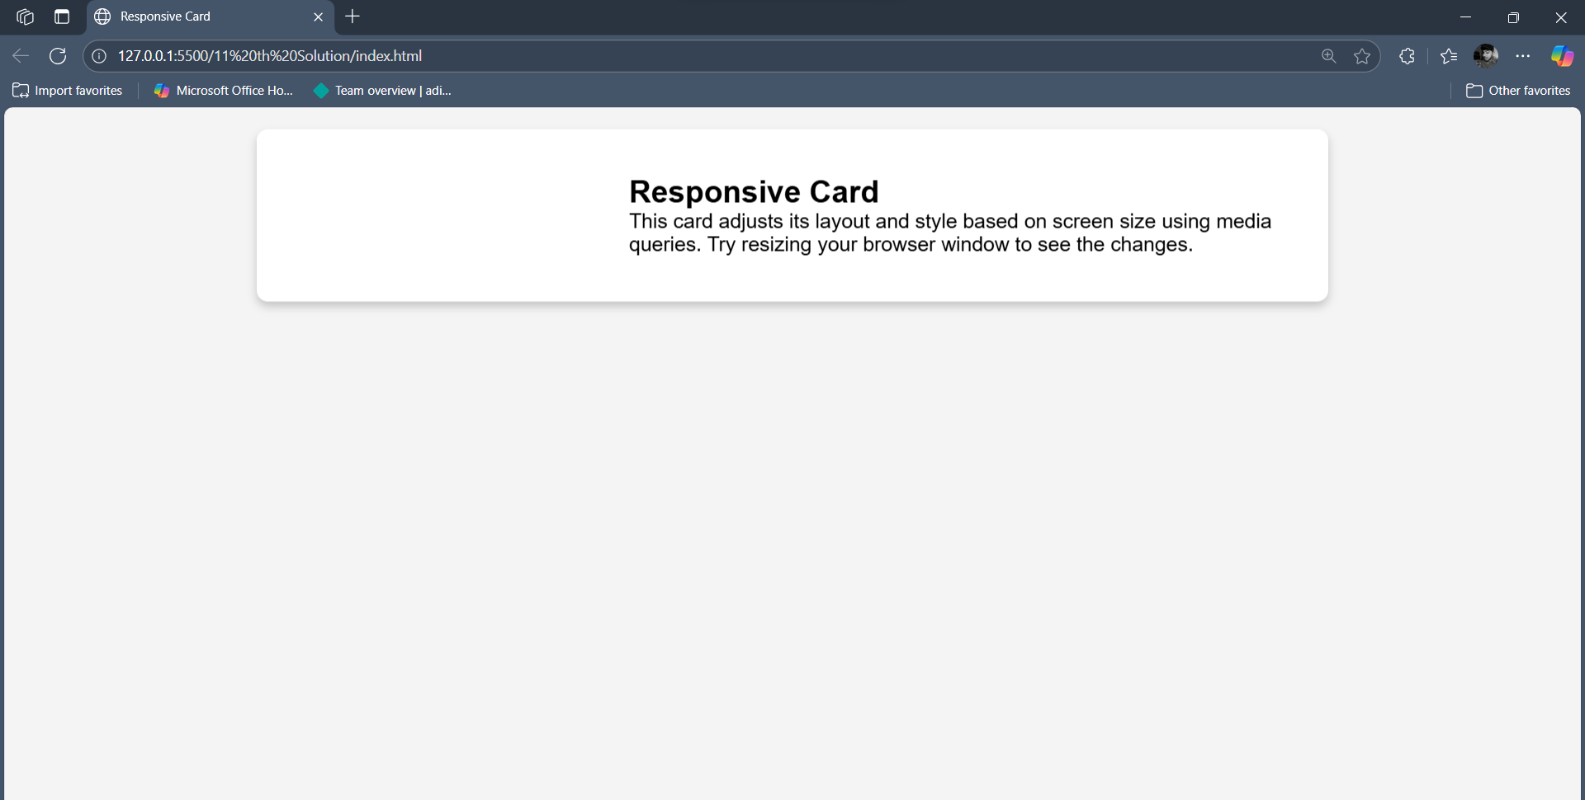

**12. Problem solution**

**@Index.html**

<!DOCTYPE html>

<html lang="en">

<head>

  <meta charset="UTF-8">

  <title>Login Form</title>

  <style>

    body {

      font-family: Arial, sans-serif;

      background: #f2f2f2;

      display: flex;

      height: 100vh;

      justify-content: center;

      align-items: center;

    }

    .login-container {

      background: #fff;

      padding: 30px;

      border-radius: 10px;

      box-shadow: 0 0 10px rgba(0,0,0,0.1);

      width: 300px;

    }

    .login-container h2 {

      text-align: center;

      margin-bottom: 20px;

    }

    .login-container label {

      display: block;

      margin-top: 10px;

    }

    .login-container input[type="email"],

    .login-container input[type="password"] {

      width: 100%;

      padding: 8px;

      margin-top: 5px;

      border: 1px solid #ccc;

      border-radius: 5px;

    }

    .login-container input[type="checkbox"] {

      margin-right: 5px;

    }

    .login-container .remember-me {

      margin-top: 10px;

    }

    .login-container button {

      width: 100%;

      margin-top: 20px;

      padding: 10px;

      background: #4CAF50;

      color: white;

      border: none;

      border-radius: 5px;

      cursor: pointer;

    }

    .login-container button:hover {

      background: #45a049;

    }

  </style>

</head>

<body>

  <div class="login-container">

    <h2>Login</h2>

    <form>

      <label for="email">Email:</label>

      <input type="email" id="email" name="email" required>

      <label for="password">Password:</label>

      <input type="password" id="password" name="password" required minlength="6">

      <div class="remember-me">

        <input type="checkbox" id="remember" name="remember">

        <label for="remember">Remember Me</label>

      </div>

      <button type="submit">Submit</button>

    </form>

  </div>

</body>

</html>

**@Output:**

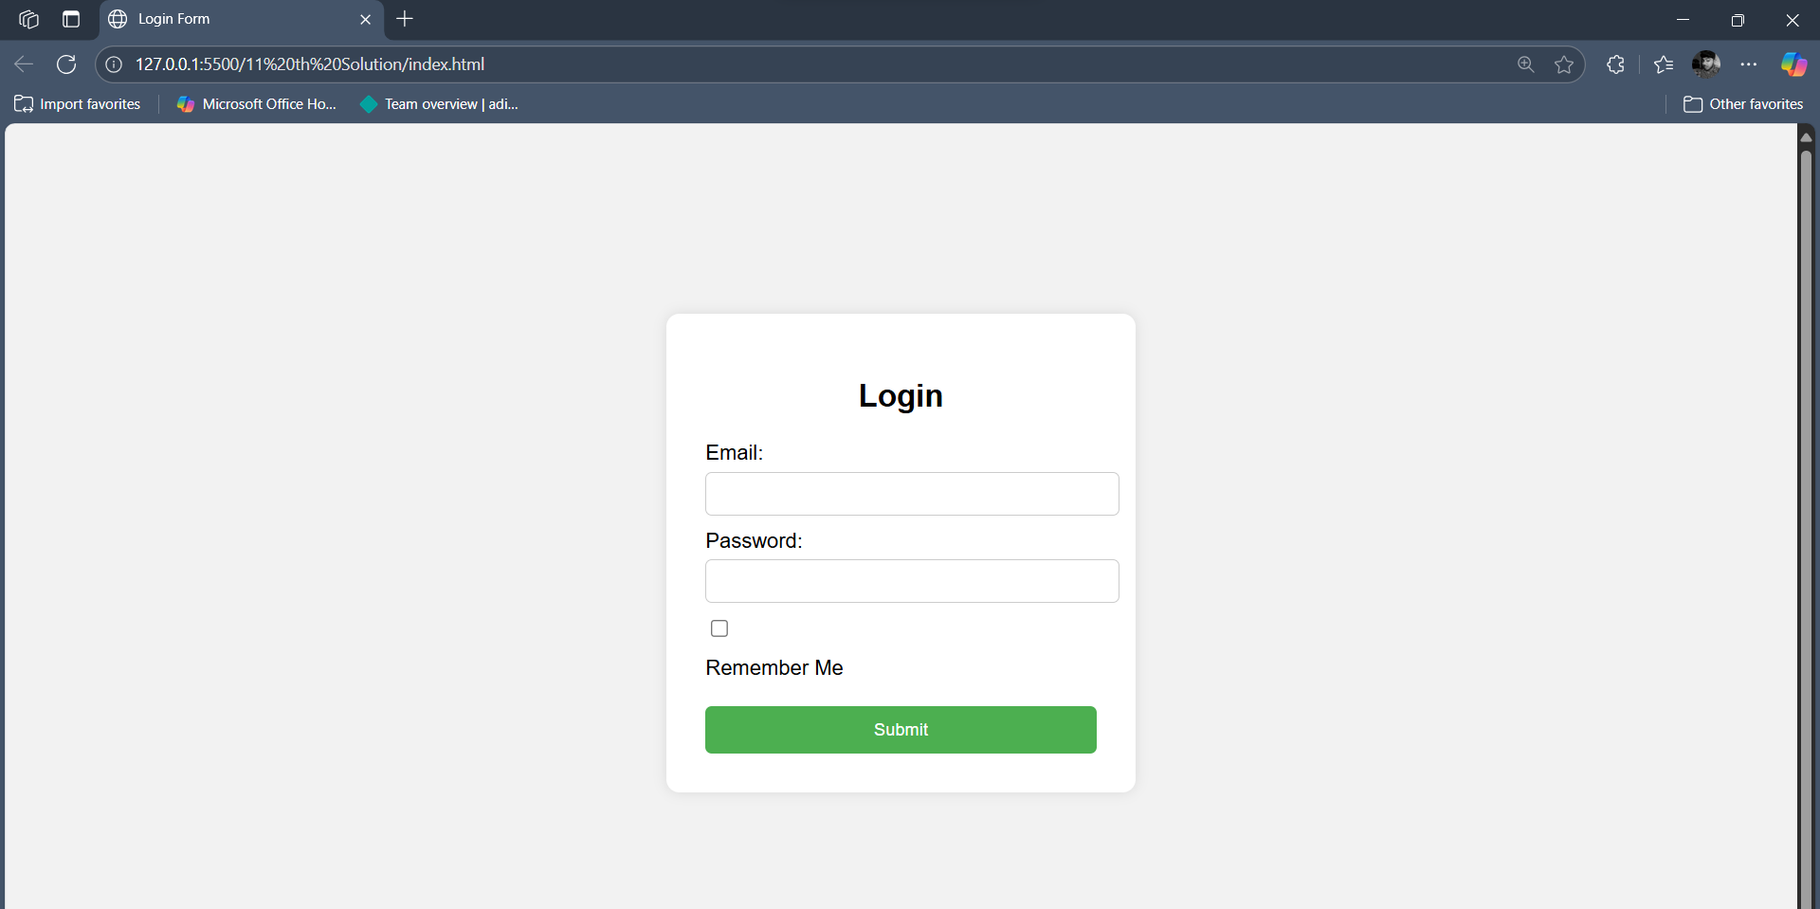

**13. Problem Solution**

**@Index.html**

<!DOCTYPE html>

<html lang="en">

<head>

  <meta charset="UTF-8">

  <title>Sticky Section Headings</title>

  <style>

    body {

      font-family: Arial, sans-serif;

      margin: 0;

      padding: 0;

      line-height: 1.6;

    }

    section {

      padding: 0 20px;

      margin-bottom: 50px;

    }

    h2 {

      position: sticky;

      top: 0;

      background-color: #f9f9f9;

      padding: 15px;

      margin: 0;

      font-size: 22px;

      border-bottom: 2px solid #ddd;

      z-index: 10;

    }

    .content {

      padding: 10px 0;

    }

    .content p {

      margin-bottom: 15px;

    }

  </style>

</head>

<body>

  <section>

    <h2>Section 1: Introduction</h2>

    <div class="content">

      <p>Lorem ipsum dolor sit amet, consectetur adipiscing elit. Sed id turpis vel elit gravida dictum.</p>

      <p>Morbi vehicula magna sed dignissim dapibus. Pellentesque in libero et quam facilisis laoreet.</p>

      <p>Aliquam erat volutpat. Suspendisse potenti. Nulla facilisi.</p>

    </div>

  </section>

  <section>

    <h2>Section 2: Features</h2>

    <div class="content">

      <p>Vivamus vehicula diam at sem fermentum, vitae lobortis lorem gravida.</p>

      <p>Curabitur tristique neque a orci finibus, vitae tincidunt elit scelerisque.</p>

      <p>Donec sed arcu at magna tincidunt congue at ac est.</p>

    </div>

  </section>

  <section>

    <h2>Section 3: Conclusion</h2>

    <div class="content">

      <p>Fusce et leo dapibus, accumsan lorem sed, facilisis massa.</p>

      <p>Sed eu velit ut velit suscipit volutpat ac ut leo.</p>

      <p>Integer posuere orci eget fermentum suscipit. Quisque vel sem id dolor feugiat lacinia.</p>

    </div>

  </section>

</body>

</html>

**Output:-**

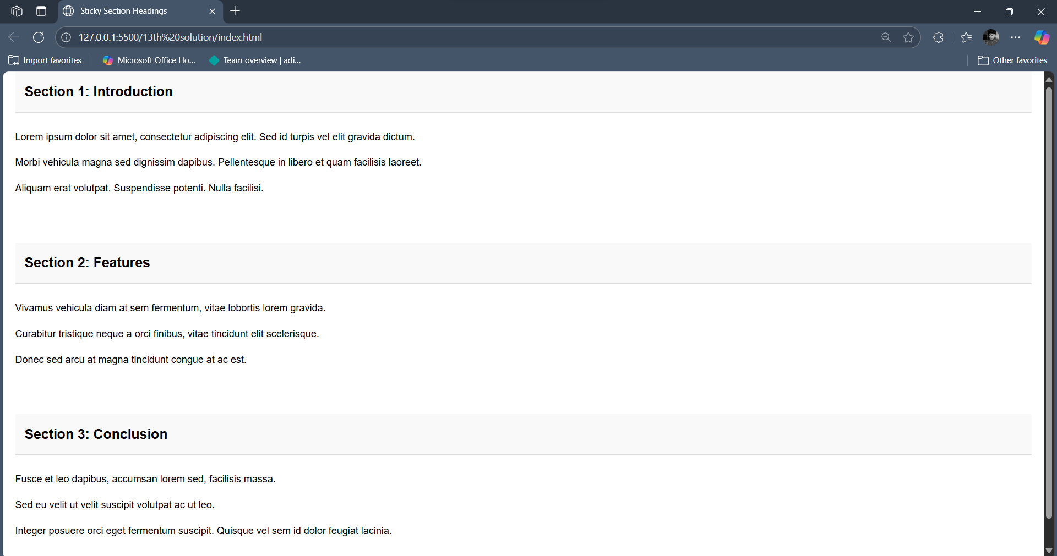

**15. Problem solution**

**@index.html**

<!DOCTYPE html>

<html>

<head>

  <title>Local & Session Storage Example</title>

</head>

<body>

  <h2>Enter Your Details</h2>

  <form id="storageForm">

    <label for="name">Name:</label>

    <input type="text" id="name" required><br><br>

    <label for="color">Favorite Color:</label>

    <input type="text" id="color" required><br><br>

    <button type="submit">Save to Storage</button>

  </form>

  <script>

    document.getElementById('storageForm').addEventListener('submit', function (e) {

      e.preventDefault();

      const name = document.getElementById('name').value;

      const color = document.getElementById('color').value;

      localStorage.setItem('userName', name);

      sessionStorage.setItem('favoriteColor', color);

      console.log("Stored in Local Storage - Name:", localStorage.getItem('userName'));

      console.log("Stored in Session Storage - Favorite Color:", sessionStorage.getItem('favoriteColor'));

      alert("Data stored successfully! Check the console.");

    });

  </script>

</body>

</html>

**@Output:-**

